Vizag Tourism Guide: Travel Guide to Explore Attractions.
Shedheesh Boni
May 26, 2020

Introduction

Background
Whenever a person searches for a venue in a new city, they’re highly interested in the best places that the city has to offer. The person might want to know what are famous in that city. This extra information would help decide which venue to choose amongst the many venues in the city. Combining the location of the venues in the city and also Neighbourhoods and Landmarks would surely help visitors in a city make better informed decisions about the places they should visit.

Mumbai is composed of a number of sectors spread across a total area of 698 sq Km. There are many venues (especially restaurants, hotels and cafes) which can be explored. This project explores various venues in Visakhapatnam and attributes the data based on popular restaurants along with Neighbourhoods and Landmarks . To explore this information, this project requires data from the Foursquare API to fetch complete information of various venues (including name, address, category, rating, latitude and longitude). Further, a map of the venues and information about these venues such as address will be plotted to identify the location to reach out. Such plots imbibe bountiful information in the form of their colored representations and location on the map. This enables any visitor to take a quick glance and decide what place to visit.

Interested audience
The target audience for such a project is twofold. Firstly, any person who is visiting Visakhapatnam, India can use the plots and maps from this project to quickly select places that suit their tastes and preferences. Secondly, a company can use this information to create a website or a mobile application, which is updated on a regular basis with additional data included, which helps individuals to explore the city or even expand same functionality to other places.

Data

Data Sources
To get location and other information about various venues in Visakhapatnam, I used Foursquare API and Web Scraping to obtain the data and decided to combine the data from both of them together but two are not equal length.

Using the Foursquare’s explore API (which gives venues recommendations), I fetched venues up to a range of 10 kilometers from the center of Visakhapatnam and collected their names, categories, locations (latitude and longitude) and address.

From Foursquare API (https://developers.foursquare.com/api), I retrieved the following for each venue:
- Name: The name of the venue.
- Category: The category type as defined by the API.
- Latitude: The latitude value of the venue.
- Longitude: The longitude value of the venue.
- Address: The particulars of the place(Inscription)

Using the Beautiful Soup package I scraped Cityscapes i.e., Neighbourhoods and Landmarks data from Visakhapatnam wikipedia page https://en.wikipedia.org/wiki/Visakhapatnam.

Scraping Neighbourhoods and Landmarks:
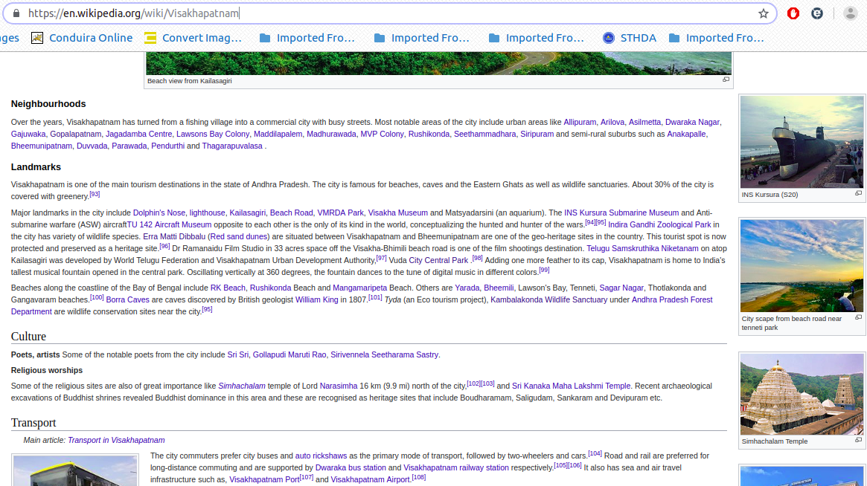

Methodology and Exploratory Data Analysis

As a first step, I retrieved the venues in Visakhapatnam from Foursquare and scraped data from wikipedia page. I extracted the location data from the Foursquare API for all venues up to a distance of 10 kilometers from the center of Visakhapatnam. Using this, I fetched the venues information such as names, latitude, longitude and address and the final data set will includes these data.

Using this dataset, I begin by analyzing the top venue types that exist in Visakhapatnam. I will then explored the venues on maps. This will allow us to better understand the location of various venues and the places where many venues co-exists and worth visiting. I also explored the venues based on the categories. The venues are plotted using proper color coding such that a simple glance at the map would reveal the location of the venues as well as give information about them. I aim to identify places which can be recommended to visitors based on their tastes and preferences. I also imposed Neighbourhoods and Landmarks to see if we can draw meaningful information out of what kind of venues exist in Visakhapatnam and which area.

As a final step, I analysed clusters of points in these plots and try to draw conclusions on what places can be recommended to visitors. I discussed my findings and any inferences I had drawn.

Categories
I begin my analysis by taking a look at the various categories of venues that exist in Visakhapatnam. As there are many restaurants, I believe that the majority venues shall include restaurants.

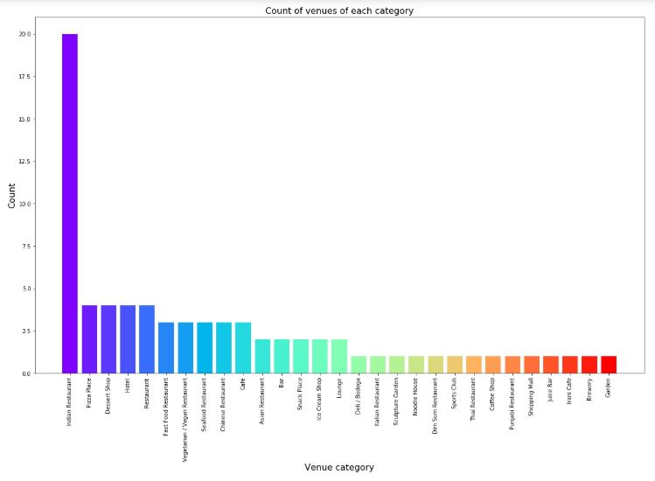
Figure 4: Count of various types of venues in Visakhapatnam
From figure 4, we see that the majority venues are actually Indian Restaurants. This is closely followed by Indian Restaurants. For someone who is visiting Visakhapatnam and loves Indian Restaurants, they’d surely love their stay.

Web Scraping

From this wikipedia [link] https://en.wikipedia.org/wiki/Visakhapatnam page; we are going to extract Cityscapes section such as Neighbourhoods and Landmarks.
- Neighbourhoods: Allipuram, Arilova, Asilmetta, Dwaraka Nagar, Gajuwaka, Gopalapatnam, Jagadamba Centre, Lawsons Bay Colony, Maddilapalem, Madhurawada, MVP Colony, Rushikonda, Seethammadhara, Siripuram, Visakhapatnam, Anakapalle, Bheemunipatnam, Duvvada, Parawada, Pendurthi, Thagarapuvalasa. *
- Landmarks: Dolphin's Nose, Lighthouse, Kailasagiri, Beach Road, Visakhapatnam, VUDA Park, Visakha Museum, INS Kursura (S20), TU 142 Aircraft Museum, Indira Gandhi Zoological Park, Erra Matti Dibbalu, Sand dunes, Telugu Samskruthika Niketanam, City Central Park, RK Beach, Rushikonda, Mangamaripeta, Yarada Beach, Bheemili Beach, Sagar Nagar, Borra Caves, William King (geologist), Kambalakonda Wildlife Sanctuary, Andhra Pradesh Forest Department.
And to display these attractions on to the Visakhapatnam map we don't have latitude and longitude readily available so, we'll be using geopy.geocoder and Nominatim to convert these addresses into latitude and longitude coordinates and then we'll pass these coordinates in to folium to impose these places on to the Vizag map.

Using get_neighbourhoods() function :
Extracts all the anchor tags in the neighbourhoods section.
After scraping we have got 21 neighbours of Visakhapatnam looks like this:
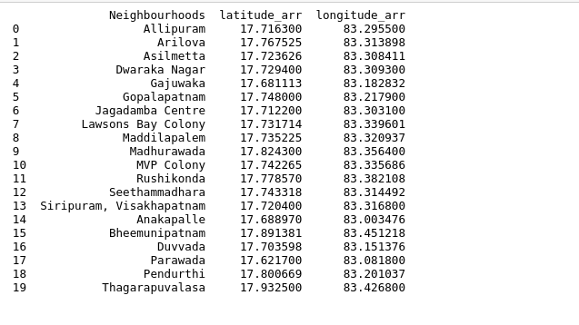

Using get_landmarks() function:

To will extracts all the anchor tags in landmarks section.
Actually there are three paragraphs in Landmarks section and each section has citations. A Citation is the way you tell your readers that certain material in your work came from another source. It also gives readers the information necessary to find that source again, including: information about the author, the title of the work.
While doing so parser is unable to parse through the code so, that's why the try and except block is used to catch and handle exceptions. Python executes code following the try statement as a “normal” part of the program (we are taking title of the anchor tag). The code that follows the except statement is the program's response to any exceptions in the preceding try clause.

We have got 23 Landmarks present in the Visakhapatnam.
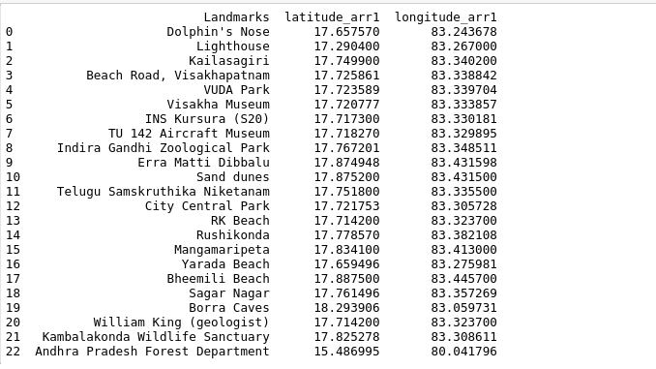

Plot showing Neighbourhoods of Visakhapatnam

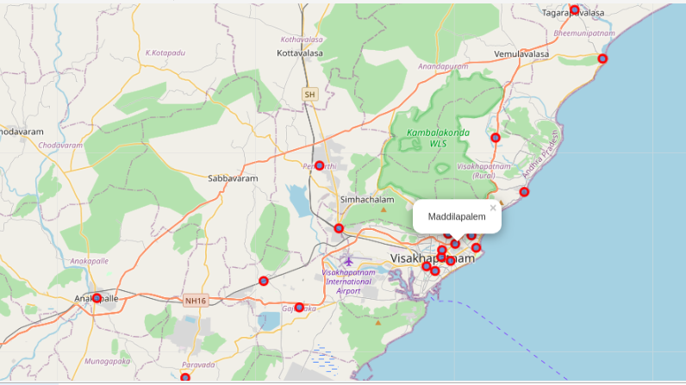

Plot showing Landmarks of Visakhapatnam along with their name

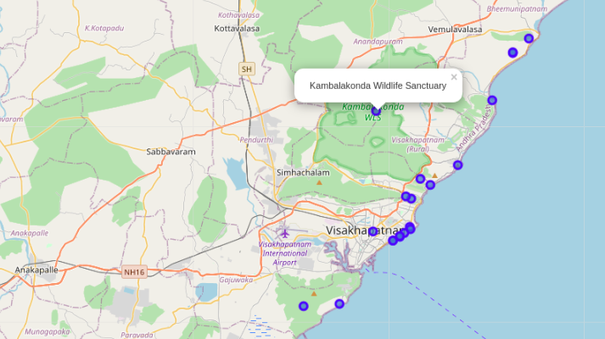
Tourist/Visitor can explore these places which exists in Visakhapatnam displayed along with address
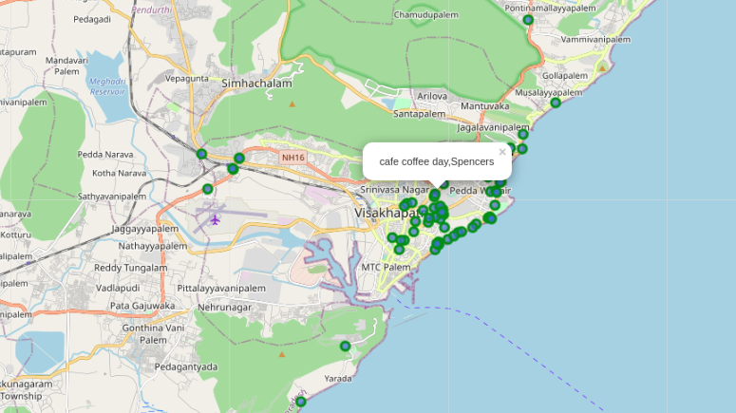

Results and Discussion

Based on our analysis above, we can draw a number of conclusions that will be useful to aid any visitor visiting the city of Visakhapatnam, India.
After collecting data from the Foursquare, we got a list of 70 different venues. We identified that from the total set of venues, majority of them were Indian Restaurants. A visitor who loves Indian food would surely like to visit Visakhapatnam.
Finally, through clusters we identified that there are many venues which are clustered around 'Varun beach', 'Rk beach', 'Siripuram', 'Sampath Vinayaka temple', 'MVP colony', 'Diamond park', 'Beach road'. On the other hand, we have visualized Neighbourhoods and Landmarks.
Most of the Landmarks are scattered at the beach corridor.
If you're looking for Indian restaurants to taste Indian food Visakhapatnam can serve wide array of varieties to enjoy the food.

A company can use this information to build up an online website/mobile application, to provide users with up to date information about various venues in the city based on the search criteria (name, rating and price) or to expand food business by keeping in mind both Neighbourhoods and Landmarks.

Conclusion

The purpose of this project was to explore the places that a person visiting Visakhapatnam could visit. The venues have been identified using Foursquare and have been plotted on the map along with that Neighbourhoods and Landmarks also plotted. The map reveals that there are seven major areas a person can visit: Varun beach, RK beach, Siripuram, Sampath Vinayaka temple, MVP colony, Diamond park and Beach road. Based on the visitor's reachability, he/she can choose amongst the places.
If a touristor visited beach corrider will cover up many places to be visited including popular venues and also including landmarks.

